Database Technologies-Assignement1

1. Create 'spj' database'. (Database for suppliers, parts and
jobs)

2. use spj database;
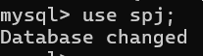

3. Create following tables in spj database.
Note : S denotes the Suppliers Table.

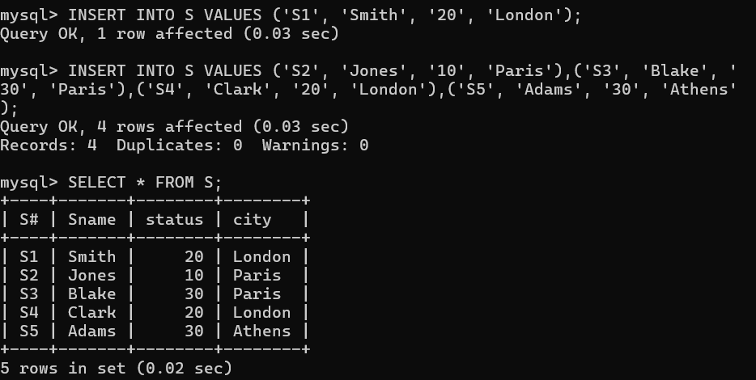

Note : P denotes the Parts table.

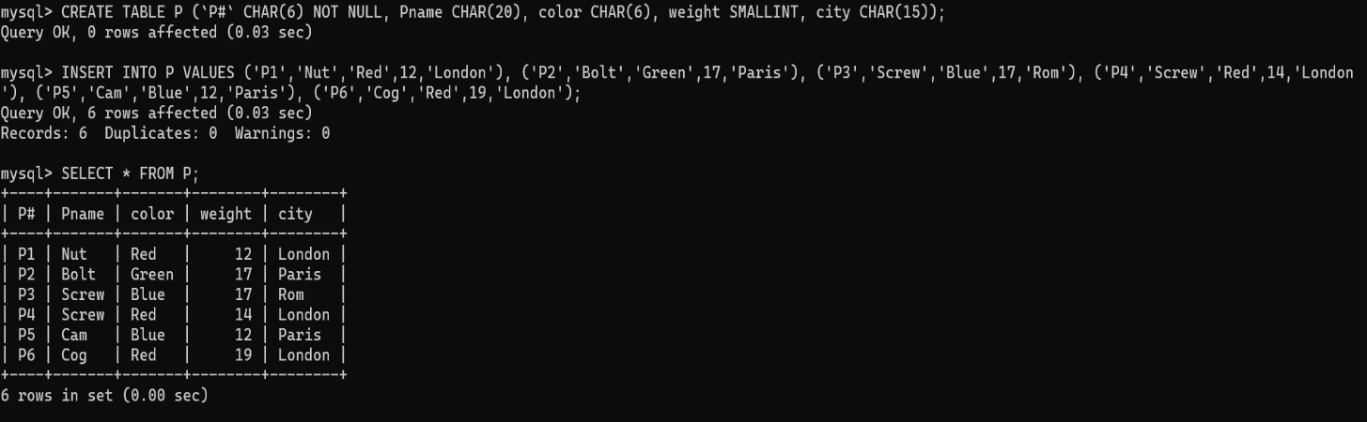
Note : J denotes the Jobs table.
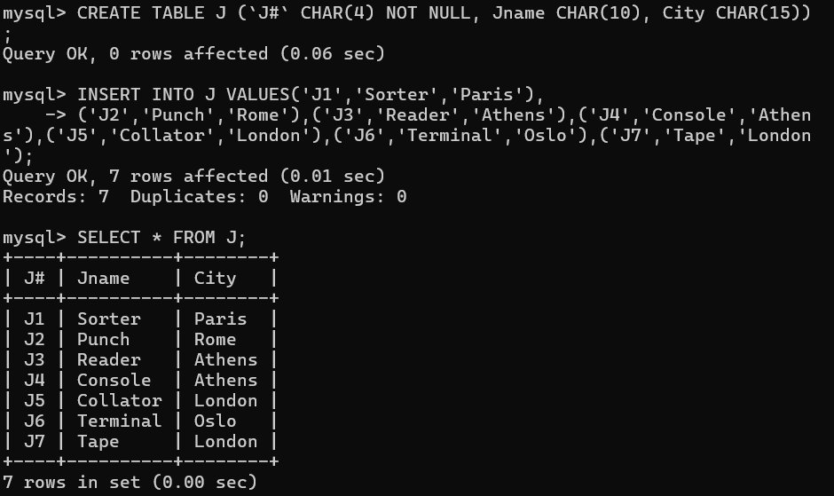

SP Table
